Objective Questions

Q1. Are there any tables with duplicate or missing null values? If so, how would you handle them?

**Output:** Check for duplicates in users table

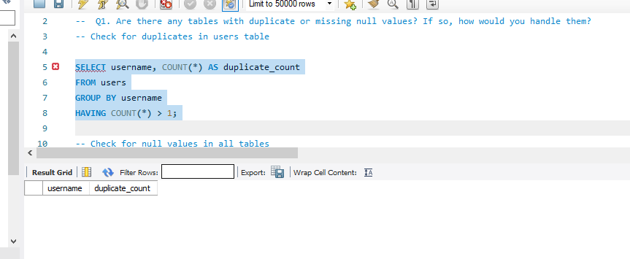

Check for null values in all tables

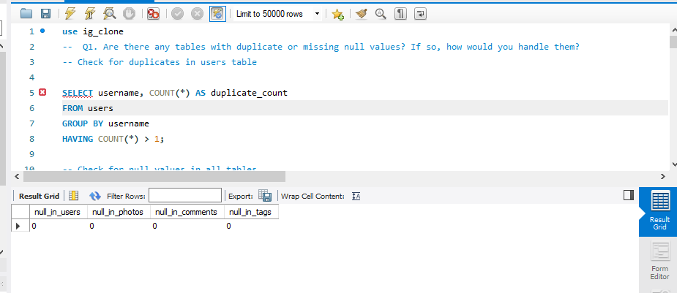

**Query:**

Check for duplicates in users table

SELECT username, COUNT(*) AS duplicate_count FROM users GROUP BY username HAVING COUNT(*) > 1;

Check for null values in all tables

SELECT (SELECT COUNT(*) FROM users WHERE username IS NULL) AS null_in_users, (SELECT COUNT(*) FROM photos WHERE image_url IS NULL) AS null_in_photos, (SELECT COUNT(*) FROM comments WHERE comment_text IS NULL) AS null_in_comments, (SELECT COUNT(*) FROM tags WHERE tag_name IS NULL) AS null_in_tags;

Q2. What is the distribution of user activity levels (e.g., number of posts, likes, comments) across the user base?

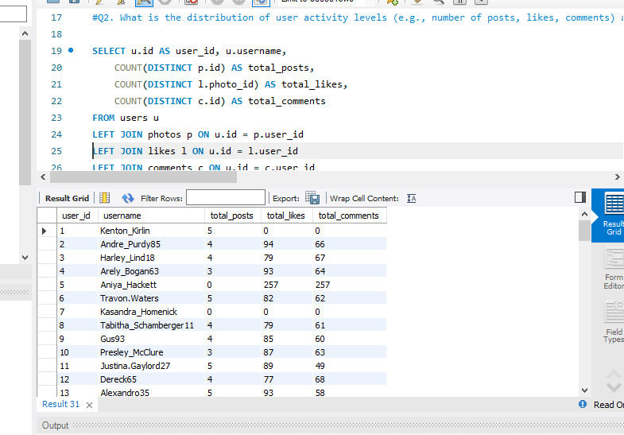**Output:**

**Visualization:**

**Query:** SELECT u.id AS user_id, u.username, COUNT(DISTINCT p.id) AS total_posts, COUNT(DISTINCT l.photo_id) AS total_likes, COUNT(DISTINCT c.id) AS total_comments FROM users u LEFT JOIN photos p ON u.id = p.user_id LEFT JOIN likes l ON u.id = l.user_id LEFT JOIN comments c ON u.id = c.user_id GROUP BY u.id, u.username;

Q3. Calculate the average number of tags per post (photo_tags and photos tables).

**Output:**

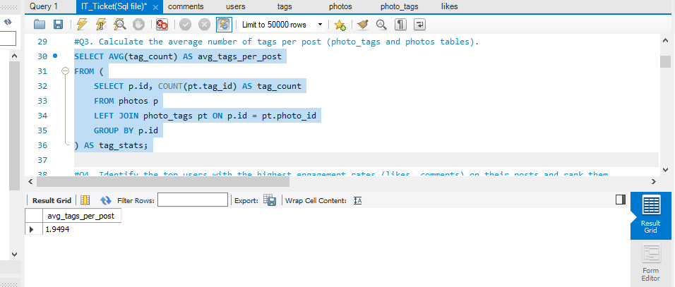 **Query:**

SELECT AVG(tag_count) AS avg_tags_per_post FROM (SELECT p.id, COUNT(pt.tag_id) AS tag_count FROM photos p LEFT JOIN photo_tags pt ON p.id = pt.photo_id GROUP BY p.id) AS tag_stats;

Q4. Identify the top users with the highest engagement rates (likes, comments) on their posts and rank them.

Output:

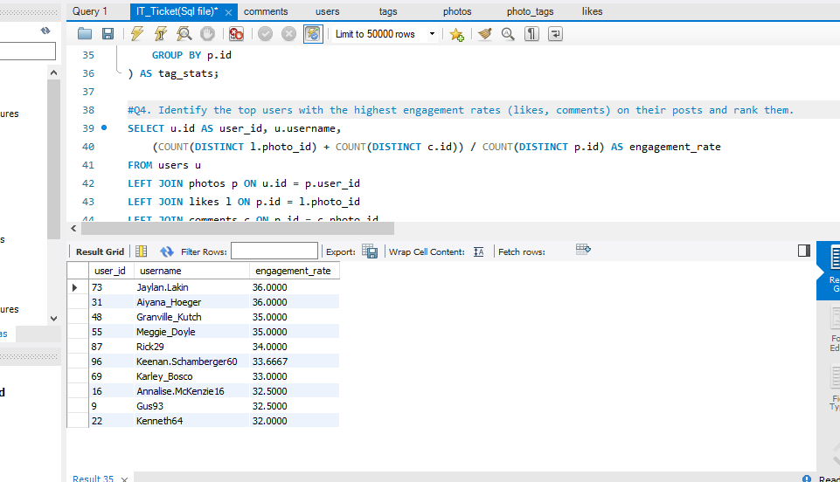

**Visualization:**

**Query:**

SELECT u.id AS user_id, u.username, (COUNT(DISTINCT l.photo_id) + COUNT(DISTINCT c.id)) / COUNT(DISTINCT p.id) AS engagement_rate FROM users u LEFT JOIN photos p ON u.id = p.user_id LEFT JOIN likes l ON p.id = l.photo_id LEFT JOIN comments c ON p.id = c.photo_id GROUP BY u.id, u.username ORDER BY engagement_rate DESC LIMIT 10;

Q5. Which users have the highest number of followers and followings?

**Output:**

-- Highest followers -- Highest followings

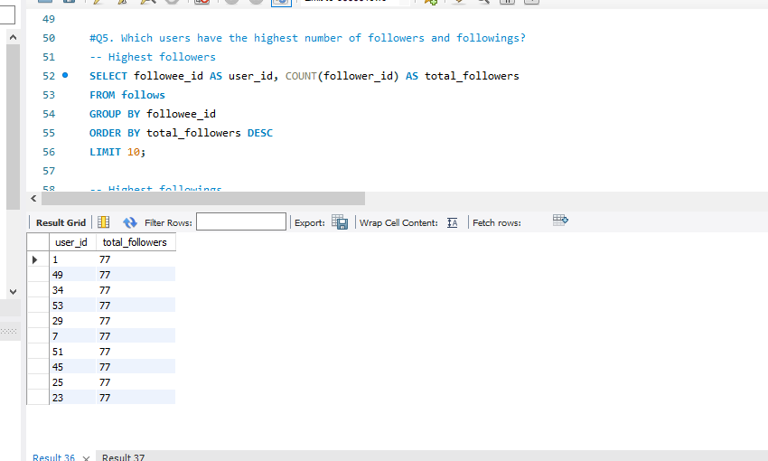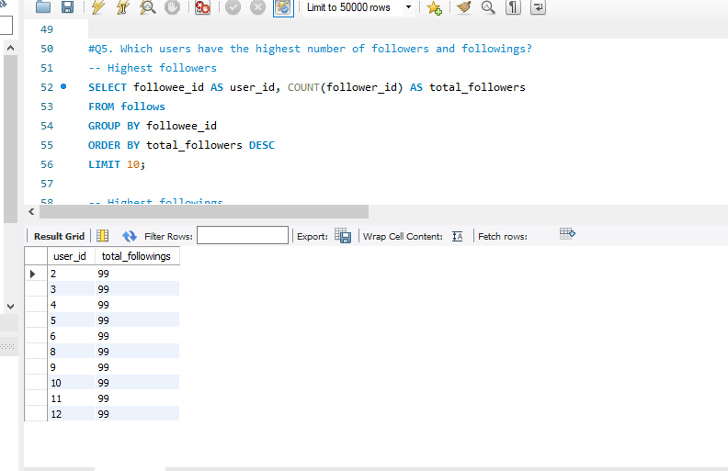

**Query:**

-- Highest followers

SELECT followee_id AS user_id, COUNT(follower_id) AS total_followers FROM follows GROUP BY followee_id ORDER BY total_followers DESC LIMIT 10;

-- Highest followings

SELECT follower_id AS user_id, COUNT(followee_id) AS total_followings FROM follows GROUP BY follower_id ORDER BY total_followings DESC LIMIT 10;

Q6. Calculate the average engagement rate (likes, comments) per post for each user.

**Output:**

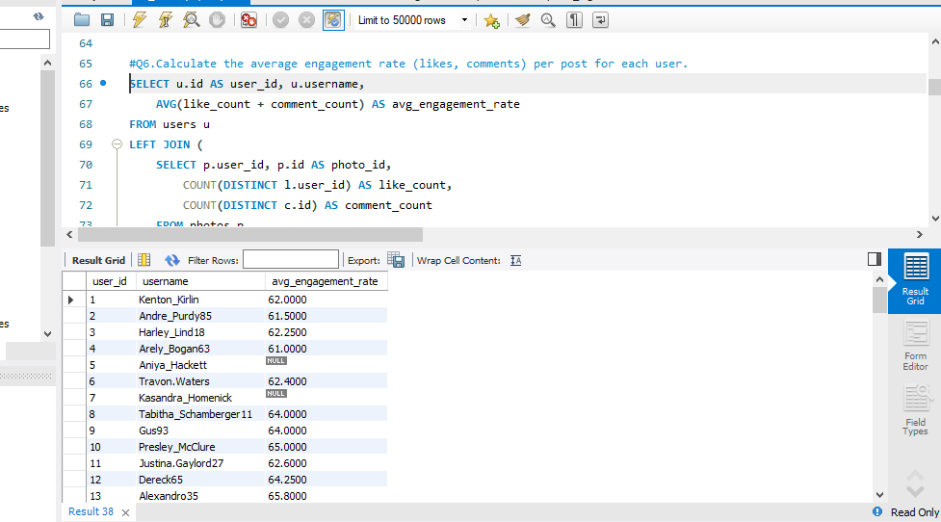

**Visualization:**

**Query:**

SELECT u.id AS user_id, u.username, AVG(like_count + comment_count) AS avg_engagement_rate FROM users u LEFT JOIN (SELECT p.user_id, p.id AS photo_id, COUNT(DISTINCT l.user_id) AS like_count, COUNT(DISTINCT c.id) AS comment_count FROM photos p LEFT JOIN likes l ON p.id = l.photo_id LEFT JOIN comments c ON p.id = c.photo_id GROUP BY p.id) AS engagement_stats ON u.id = engagement_stats.user_id GROUP BY u.id, u.username;

Q7. Get the list of users who have never liked any post (users and likes tables)

**Output:**

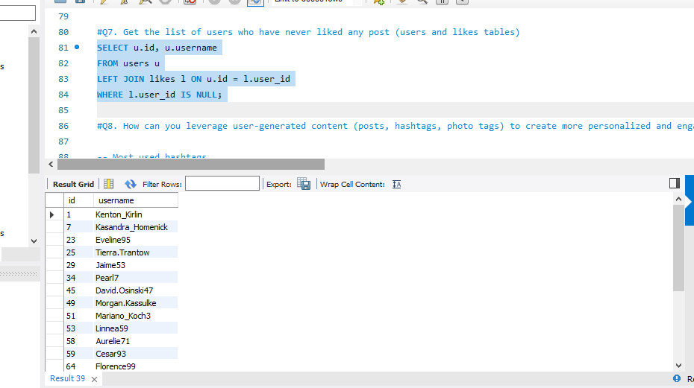

**Query:** SELECT u.id, u.username FROM users u LEFT JOIN likes l ON u.id = l.user_id WHERE l.user_id IS NULL;

Q8. How can you leverage user-generated content (posts, hashtags, photo tags) to create more personalized and engaging ad campaigns?

**Output:**

-- Most used hashtags

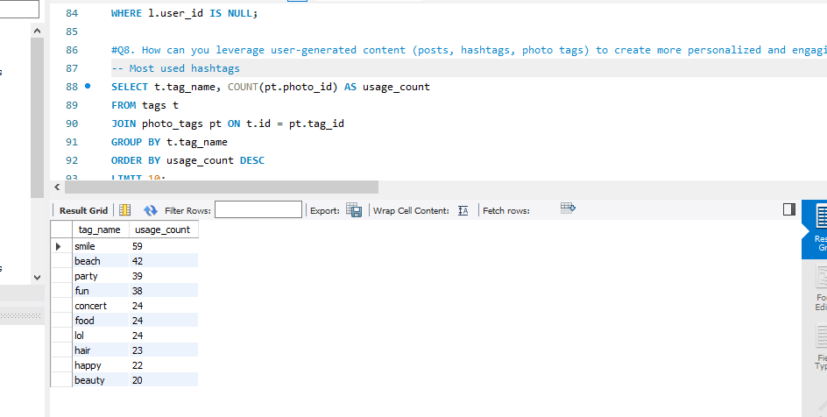

-- Most engaged content types

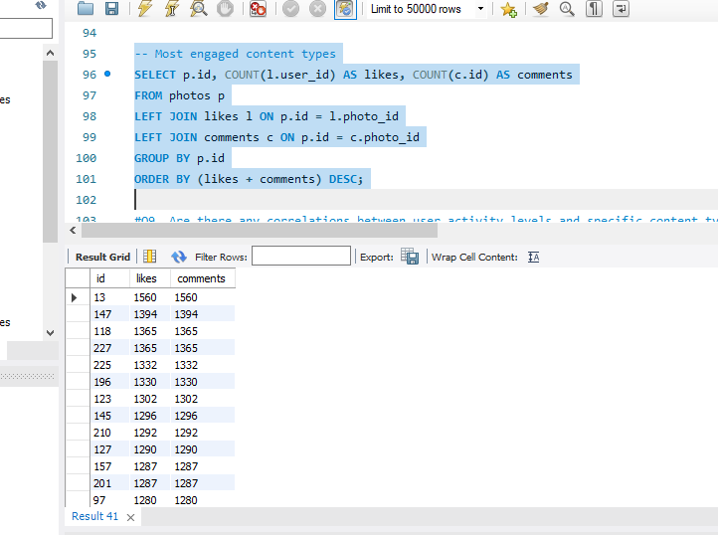

**Visualization:**

-- Most used hashtags

-- Most engaged content types

**Query:**

-- Most used hashtags

SELECT t.tag_name, COUNT(pt.photo_id) AS usage_count FROM tags t JOIN photo_tags pt ON t.id = pt.tag_id GROUP BY t.tag_name ORDER BY usage_count DESC LIMIT 10;

-- Most engaged content types

SELECT p.id, COUNT(l.user_id) AS likes, COUNT(c.id) AS comments FROM photos p LEFT JOIN likes l ON p.id = l.photo_id LEFT JOIN comments c ON p.id = c.photo_id GROUP BY p.id ORDER BY (likes + comments) DESC;

Q9. Are there any correlations between user activity levels and specific content types (e.g., photos, videos, reels)? How can this information guide content creation and curation strategies?

**Output:**

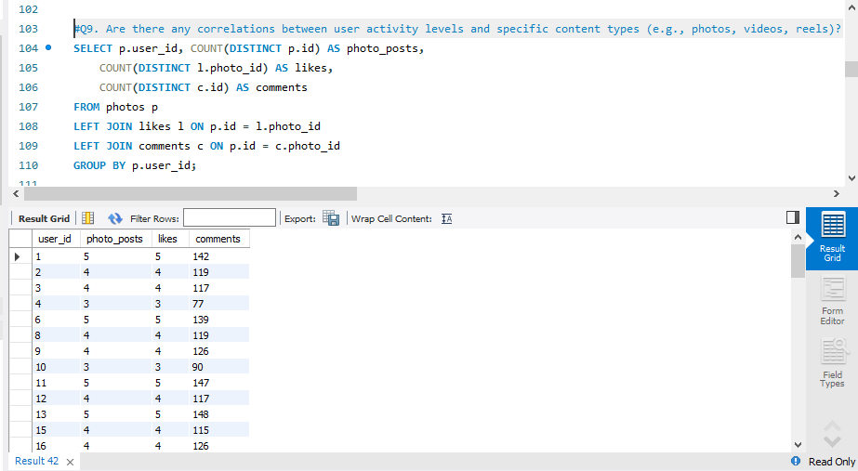

**Query:**

SELECT p.user_id, COUNT(DISTINCT p.id) AS photo_posts, COUNT(DISTINCT l.photo_id) AS likes, COUNT(DISTINCT c.id) AS comments FROM photos p LEFT JOIN likes l ON p.id = l.photo_id LEFT JOIN comments c ON p.id = c.photo_id GROUP BY p.user_id;

Q10. Calculate the total number of likes, comments, and photo tags for each user.

**Output:**

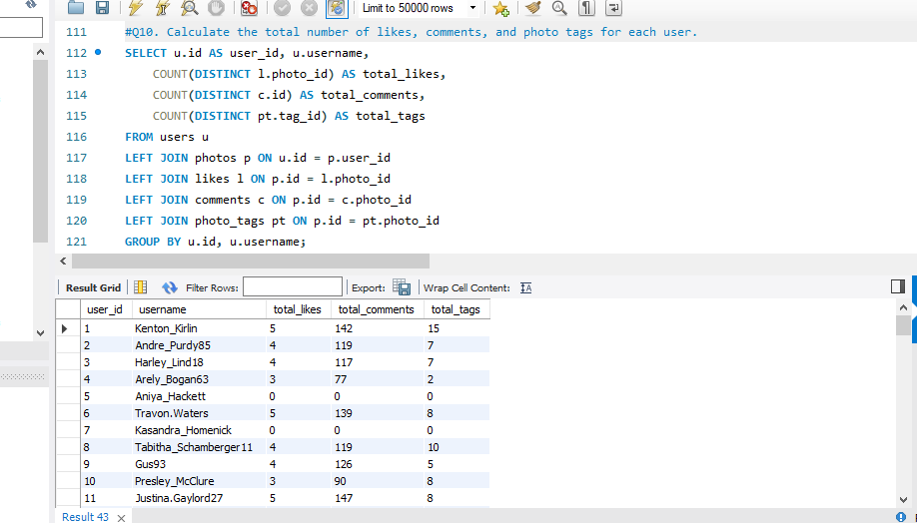

**Visualization:**

**Query:**

SELECT u.id AS user_id, u.username, COUNT(DISTINCT l.photo_id) AS total_likes, COUNT(DISTINCT c.id) AS total_comments, COUNT(DISTINCT pt.tag_id) AS total_tags FROM users u LEFT JOIN photos p ON u.id = p.user_id LEFT JOIN likes l ON p.id = l.photo_id LEFT JOIN comments c ON p.id = c.photo_id LEFT JOIN photo_tags pt ON p.id = pt.photo_id GROUP BY u.id, u.username;

Q11. Rank users based on their total engagement (likes, comments, shares) over a month.

**Output:**

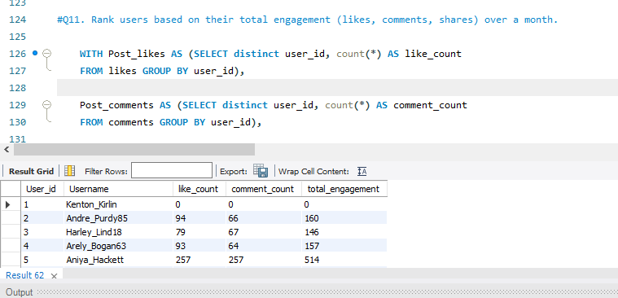

**Query:**

WITH Post_likes AS (SELECT distinct user_id, count(*) AS like_count FROM likes GROUP BY user_id),

Post_comments AS (SELECT distinct user_id, count(*) AS comment_count FROM comments GROUP BY user_id),

Total_likes_n_comments AS (SELECT distinct u.id AS User_id, u.username, coalesce(pl.like_count, 0) AS like_count, coalesce(pc.comment_count, 0) AS comment_count, coalesce(pl.like_count, 0) + coalesce(pc.comment_count, 0) AS total_engagement FROM users as u LEFT JOIN Post_likes as pl ON u.id=pl.user_id LEFT JOIN Post_comments as pc ON u.id=pc.user_id)

select User_id , username as Username , like_count , comment_count , total_engagement from Total_likes_n_comments ;

Q12. Retrieve the hashtags that have been used in posts with the highest average number of likes. Use a CTE to calculate the average likes for each hashtag first.

**Output:**

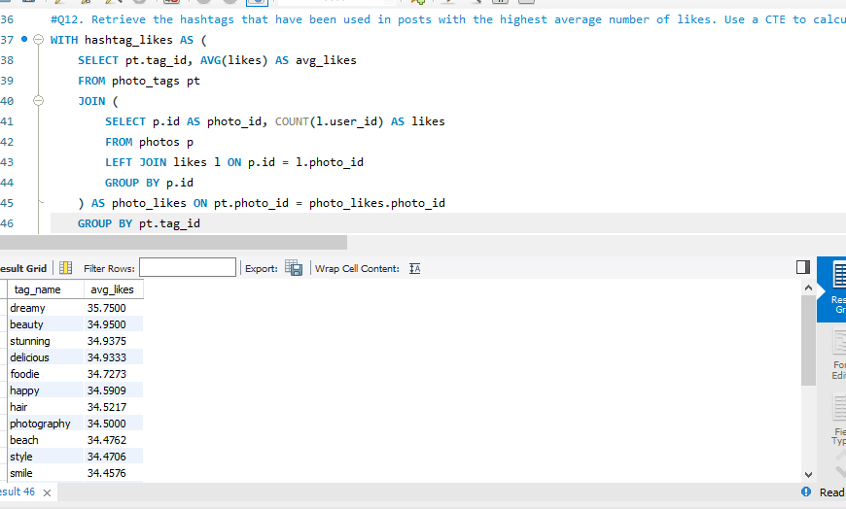

**Visualization:**

**Query:** WITH hashtag_likes AS ( SELECT pt.tag_id, AVG(likes) AS avg_likes FROM photo_tags pt JOIN ( SELECT p.id AS photo_id, COUNT(l.user_id) AS likes FROM photos p LEFT JOIN likes l ON p.id = l.photo_id GROUP BY p.id) AS photo_likes ON pt.photo_id = photo_likes.photo_id GROUP BY pt.tag_id)

SELECT t.tag_name, hl.avg_likes FROM hashtag_likes hl JOIN tags t ON hl.tag_id = t.id ORDER BY hl.avg_likes DESC;

Q13. Retrieve the users who have started following someone after being followed by that person

**Output:**

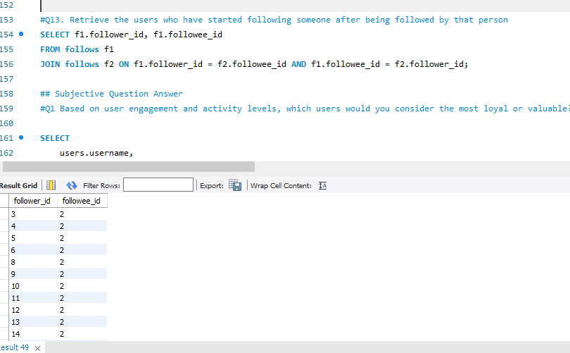

**Query:**

SELECT distinct f1.follower_id, distinct f1.followee_id FROM follows f1 JOIN follows f2 ON f1.follower_id = f2.followee_id AND f1.followee_id = f2.follower_id;

Subjective Questions

1. Based on user engagement and activity levels, which users would you consider the most loyal or valuable? How would you reward or incentivize these users?

**Analysis**:

**Identifying the Most Loyal or Valuable Users:** To determine the most loyal and valuable users, we need to analyze engagement metrics such as:

* **Number of likes received and given** – Indicates active participation and appreciation of content.
* **Comments made** – Shows deeper interaction and discussion on the platform.
* **Posts shared** – Measures user contribution and content generation.
* **Follower-to-engagement ratio** – Helps identify influencers or dedicated users who engage meaningfully rather than just accumulating followers.
* **Time spent on platform** – Indicates overall interest and loyalty.

By analyzing these metrics, we can rank users based on their total contribution and engagement levels.

**Queries to Use**:

* Calculate total engagement per user: SELECT users.username, COUNT(likes.user_id) + COUNT(comments.user_id) AS total_engagement FROM users LEFT JOIN likes ON likes.user_id = users.id LEFT JOIN comments ON comments.user_id = users.id GROUP BY users.id;
* Rank users based on the total_engagement metric.

**Table:**

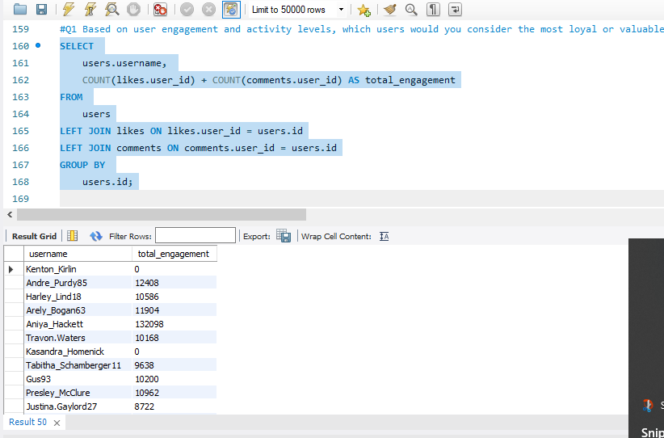

**Rewarding and Incentivizing High-Value Users:**

Once we have identified the top users based on engagement, we can implement various incentives to encourage continued activity.

#### ****1. Exclusive Features & Beta Access****

* Provide early access to new features such as premium filters, analytics tools, or customization options.
* Offer them the ability to test and provide feedback on upcoming platform updates.

#### ****2. Recognition & Social Validation****

* Create a **leaderboard or top contributor list** visible to the community.
* Feature their content in **newsletters, recommendation feeds, or platform highlights** to boost their visibility.
* Award badges or special status (e.g., “Top Creator” or “Super User”).

#### ****3. Monetary Rewards & Perks****

* Offer **discounts, exclusive coupons, or gift cards** for reaching specific engagement milestones.
* Introduce a **loyalty points system**, where users earn redeemable points for consistent activity.

#### ****4. Content Visibility Boosting****

* Algorithmically **increase the visibility** of highly engaged users’ content to reward their participation.
* Provide **free promotional credits** for posts or stories.

#### ****5. Personalized Engagement****

* Assign a dedicated **community manager or brand ambassador** to engage directly with top users.
* Send **personalized thank-you messages or shoutouts** from the official platform.

By implementing a combination of these strategies, platforms can not only retain their most valuable users but also encourage new users to engage more actively.

1. For inactive users, what strategies would you recommend to re-engage them and encourage them to start posting or engaging again?

**Analysis:** Inactive users can be identified as those who haven’t performed key actions (posting, liking, or commenting) within a certain timeframe, such as the last 30 days. These users may have lost interest, found other platforms more engaging, or simply forgotten about the platform. A well-structured re-engagement strategy can help bring them back.

* + Users who have not posted, liked, or commented in the last 30 days.  
    Query to find such users: SELECT username FROM users WHERE id NOT IN ( SELECT DISTINCT user_id FROM likes WHERE created_at > NOW() - INTERVAL 30 DAY UNION SELECT DISTINCT user_id FROM comments WHERE created_at > NOW() - INTERVAL 30 DAY);

**Table:**

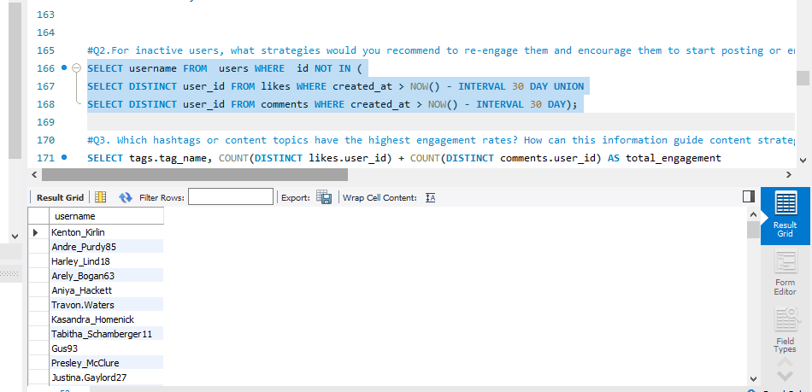

**Visualization:**

**Strategies**

1. **Targeted Campaigns & Personalized Outreach**:

**Email & Push Notifications:**

* + - * Send personalized messages reminding them of their last activity.
      * Showcase **trending content** in their favorite categories.
      * Highlight posts from their **friends or followed accounts** that they missed.
      * Example notification: *"Hey [User], your friends have been sharing amazing moments! Come check out what’s trending today!"*

1. **Gamification & Challenges** :

* Introduce **challenges and rewards** to make engagement fun.
* Example:*"Post 3 photos this week and unlock a special badge!"*
* Offer **streak-based rewards** (e.g., log in and engage for 5 days to earn points).
* Use **leaderboards and competitive elements** to encourage friendly competition.

1. **AI-Powered Content Recommendations:**

* Use **machine learning models** to analyze their past behavior and recommend trending topics.
* Example: *"Your favorite hashtag, #SunsetPhotography, is trending! Share your best shot today!"*
* Provide a **personalized feed refresh** to make the platform feel new and exciting again.

1. **Rewarding Return Activity**:

* Offer **instant engagement boosts** for their first post after returning (e.g., increase visibility, prioritize on explore page).
* Provide **bonus points, coins, or in-app currency** that can be used for exclusive content or perks.

1. Which hashtags or content topics have the highest engagement rates? How can this information guide content strategy and ad campaigns?

**Analysis:** Understanding which hashtags or content topics drive the most engagement can help **optimize user-generated content, boost platform-wide challenges, and refine ad targeting**. By analyzing engagement metrics, platforms can **enhance organic reach, increase user participation, and improve ad performance**.

* Join the tags, photo_tags, photos, likes, and comments tables.
* Aggregate likes and comments for each hashtag.
* Query: SELECT tags.tag_name, COUNT(likes.id) + COUNT(comments.id) AS total_engagement FROM tags JOIN photo_tags ON photo_tags.tag_id = tags.id JOIN photos ON photos.id = photo_tags.photo_id LEFT JOIN likes ON likes.photo_id = photos.id LEFT JOIN comments ON comments.photo_id = photos.id GROUP BY tags.tag_name ORDER BY total_engagement DESC;

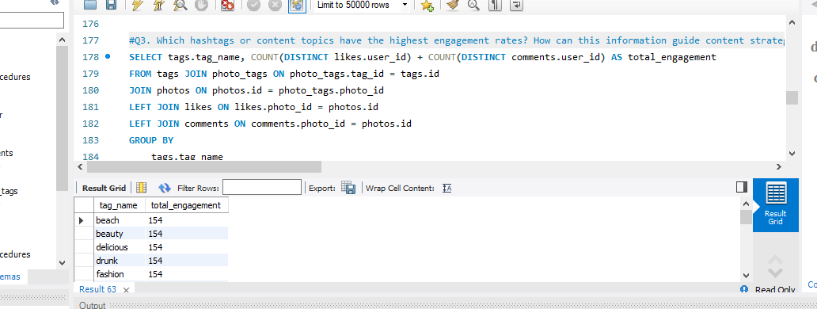 **Table:**

**Visualization:**

**Strategy: Analyzing High-Performing Hashtags**

To determine which hashtags have the highest engagement, we analyze the **likes, comments, and shares** associated with each hashtag. The following approach ensures accurate identification of top hashtags:

**Applying Insights to Content Strategy**

**1. Use High-Performing Hashtags in User-Generated Content (UGC) Campaigns** Encouraging users to **adopt trending hashtags** in their posts helps boost organic reach and interaction.

Example: If #SunsetPhotography is trending, launch a "Best Sunset Shot" contest and feature winners on the homepage.

Reward active participants with profile boosts, exclusive filters, or small incentives.

**Collaborations & Influencers:**

* Partner with influencers who already use these hashtags to increase visibility.
* Encourage influencers to create **challenge-based content** using the trending hashtags.

**Gamified Engagement:**

* Offer **badges or points** for users who frequently post with trending hashtags. Example: "Use #FoodieDiaries 10 times this month and unlock an exclusive badge!"

**2. Platform-Wide Hashtag Challenges**

Creating platform-wide challenges with high-engagement hashtags can encourage user participation and content sharing.

**Implementation Strategy:**

1. **Trending Hashtag Competitions:** Example: "Use #MyBestOutfit and get featured on our explore page!" Show a **leaderboard** of the most engaged posts using the hashtag.
2. **Limited-Time Campaigns:** Feature weekly or monthly **hashtag themes** that align with user preferences. Example: "This week’s hashtag is #WeekendVibes—share your best weekend moments!"
3. **Interactive Elements:** Add **stickers, filters, or badges** for posts that use high-performing hashtags. Example: If #ArtLovers is trending, provide **art-themed frames** for users who post with that hashtag.

**Step 3: Optimizing Ad Campaigns Using High-Performing Hashtags**

1. **Target Ads Based on Trending Hashtags**

High-engagement hashtags indicate topics users are actively interested in. This data can **guide ad placements and improve ROI**.

**Strategies for Ad Targeting:**

* **Run Ads for Related Products & Services:** If #FitnessJourney is trending, **target gym memberships, sportswear, or health products** to users engaging with that hashtag. Example: "Loving #FitnessJourney? Try our premium workout gear at 20% off!"
* **Promote Sponsored Posts with Top Hashtags:** Ensure paid content includes the **highest-performing hashtags** to increase visibility and engagement. Example: A **travel agency** running an ad campaign might use **#AdventureAwaits** if it’s currently trending.

1. **Retarget Users Engaging with High-Performing Hashtags**

Users engaging with certain hashtags are **highly interested in related topics**. Running **retargeting ads** for these users can improve conversion rates.

* **Implementation Approach:** **Track users who like/comment on posts with trending hashtags.** **Show them targeted ads based on their interests.** Example: Users engaging with #VeganEats see an ad for a new plant-based restaurant.

**A/B test different hashtags in ads** to determine which ones drive the most conversions.

1. Are there any patterns or trends in user engagement based on demographics (age, location, gender) or posting times? How can these insights inform targeted marketing campaigns?

**Analysis:**

Understanding engagement patterns based on **age, location, gender, and posting times** helps in **optimizing content strategy, increasing engagement, and improving ad targeting**. By leveraging these insights, businesses can **maximize visibility, improve user retention, and increase ad effectiveness**.

**Query:**

With Likes as (SELECT photo_id, COUNT(*) AS Total_likes FROM likes GROUP BY photo_id) , Comments as (SELECT photo_id, COUNT(*) AS Total_comments FROM comments GROUP BY photo_id)

SELECT DATE_FORMAT(p.created_dat, '%H') AS Hour_of_day, DAYNAME(p.created_dat) AS Day_of_week, COUNT(p.id) AS Total_posts, COALESCE(SUM(L.Total_likes), 0) AS Total_likes, COALESCE(SUM(c.Total_comments), 0) AS Total_comments, ROUND((COALESCE(SUM(l.Total_likes), 0) + COALESCE(SUM(c.Total_comments), 0)) / COUNT(p.id),0) AS Average_engagement FROM photos AS p LEFT JOIN Likes as l ON p.id = l.photo_id LEFT JOIN Comments as c ON p.id = c.photo_id GROUP BY Hour_of_day,Day_of_week ;

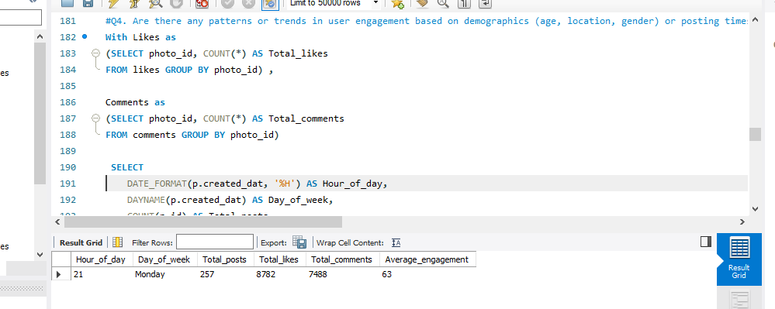 **Table:**

**Marketing Insights:**

**1. Target High-Engagement Age Groups & Locations for Ads**

**Identify which age groups and locations engage the most** (e.g., if **18-24 users in New York** have the highest engagement, focus ads there).

**Adjust ad copy & visuals based on audience demographics** (e.g., younger users may prefer dynamic, video-based ads, while older groups might engage more with informative content).

**Marketing Strategy:**

✔ **Geo-targeted ads** based on high-engagement locations.  
✔ **Age-specific promotions** (e.g., discounts for Gen Z users).  
✔ **Localized content** (e.g., regional festivals or trends).

**2. Optimize Posting Times for Maximum Visibility**

**Identify peak engagement hours & days** (e.g., if engagement is highest at **7-9 PM on weekends**, prioritize scheduling posts then).

**Time-sensitive promotions** can be launched at **high-engagement windows**.

**Marketing Strategy:**

✔ **Schedule posts during peak hours** for organic reach.  
✔ **Launch time-limited deals** right before high-engagement periods.  
✔ **Use push notifications/emails** reminding users to engage at peak times.

**3. Segment & Personalize Campaigns by Gender & Location**

If **women engage more with fashion-related posts at night**, create **personalized ads** targeting this segment.

If **men in a specific region interact more with tech-related content**, tailor campaigns accordingly.

**Marketing Strategy:**

✔ **Gender-based promotions** (e.g., discounts for women’s fashion during their most active hours).  
✔ **Regional campaigns** with localized offers.  
✔ **AI-driven content recommendations** based on individual engagement history.

1. Based on follower counts and engagement rates, which users would be ideal candidates for influencer marketing campaigns? How would you approach and collaborate with these influencers?

**Analysis:** Find ideal influencer candidates based on **follower count and engagement rates** and develop strategies for effective collaboration.

1. High follower counts (follower_count from the follows table).
2. High engagement rates (likes and comments per post).

Query to identify influencers: WITH Followers AS ( SELECT f.follower_id AS user_id, COUNT(f.follower_id) AS follower_count FROM follows f GROUP BY f.follower_id), total_likes_n_comments AS ( SELECT p.user_id, COUNT(DISTINCT l.user_id) AS total_likes, COUNT(DISTINCT c.id) AS total_comments FROM photos p LEFT JOIN likes l ON p.id = l.photo_id LEFT JOIN comments c ON p.id = c.photo_id GROUP BY p.user_id), Final AS ( SELECT u.id, u.username as Username, coalesce(sum(f.follower_count),0) as Follower_count, coalesce(sum(t.total_likes),0) AS Total_likes, coalesce(sum(t.total_comments),0) AS Total_comments, Round(coalesce(sum(t.total_likes), 0) + coalesce(sum(t.total_comments),0) / coalesce(count(f.follower_count),1),0) AS Engagement_rate FROM users u LEFT JOIN Followers f ON u.id = f.user_id LEFT JOIN total_likes_n_comments t ON u.id = t.user_id group by u.id ,u.username )

SELECT id AS User_id, Username, Follower_count, Total_likes, Total_comments, Engagement_rate FROM Final where Follower_count != 0 ORDER BY engagement_rate DESC, follower_count DESC limit 10;

**Approach**

* + Create tiered influencer programs (e.g., micro, macro influencers).
  + Collaborate on content aligned with platform goals (e.g., promoting a new feature).

Offer exclusive benefits such as free services or revenue-sharing opportunities

1. Based on user behavior and engagement data, how would you segment the user base for targeted marketing campaigns or personalized recommendations?

**Segmentation:**

1. Engagement Levels:

* High activity: Frequent posters, likers, and commenters.
* Moderate activity: Users with occasional engagement.
* Low activity: Inactive users.

2. Content Preferences:

* Analyze liked photos and hashtags to categorize users by interest.

3. Demographics:

* Segment by age, gender, or location for personalized campaigns.

4. Posting Behavior:

* Frequent posters can be encouraged with analytics on their engagement trends.
* Occasional users can be incentivized to post more.

**Query:**

With Likes as (SELECT user_id, COUNT(*) AS likes_count

FROM likes GROUP BY user_id), Comments as (SELECT user_id, COUNT(*) AS comments_count FROM comments GROUP BY user_id)

SELECT u.id AS user_id, u.username, COALESCE(SUM(likes_count), 0) AS Total_likes,

COALESCE(SUM(comments_count), 0) AS Total_comments, COALESCE(COUNT(DISTINCT p.id), 0) AS Total_photos, CASE WHEN COALESCE(COUNT(DISTINCT p.id), 0) = 0 THEN 0 ELSE (COALESCE(SUM(likes_count), 0) + COALESCE(SUM(comments_count), 0)) / COALESCE(COUNT(DISTINCT p.id), 1) END AS Engagement_rate, CASE WHEN COALESCE(COUNT(DISTINCT p.id), 0) = 0 THEN 'Inactive Users' WHEN (COALESCE(SUM(likes_count), 0) + COALESCE(SUM(comments_count), 0)) / COALESCE(COUNT(DISTINCT p.id), 1) > 150 THEN 'Ative Users' WHEN (COALESCE(SUM(likes_count), 0) + COALESCE(SUM(comments_count), 0)) / COALESCE(COUNT(DISTINCT p.id), 1) BETWEEN 100 AND 150 THEN 'Moderately Active Users' ELSE 'Inactive Users' END AS Engagement_level FROM users as u LEFT JOIN photos p ON u.id = p.user_id LEFT JOIN Likes as l ON u.id = l.user_id LEFT JOIN Comments as c

ON u.id = c.user_id GROUP BY u.id, u.username ORDER BY engagement_rate DESC;

**Output:**

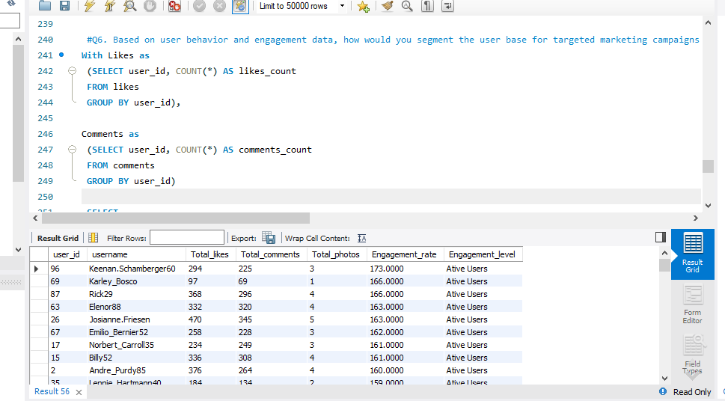

1. If data on ad campaigns (impressions, clicks, conversions) is available, how would you measure their effectiveness and optimize future campaigns?

**Measuring & Optimizing Ad Campaign Effectiveness**

Ad campaign success depends on tracking key performance metrics and continuously refining strategies to maximize engagement and conversions.

**1. Measuring Ad Campaign Effectiveness:** To assess the performance of ad campaigns, we analyze multiple KPIs:

* **Impressions & Reach**

**Definition**: The total number of times an ad is displayed.

**Importance**: High impressions indicate strong visibility but do not guarantee engagement.

**Optimization**: Low engagement with high impressions suggests the need for better ad copy, visuals, or targeting.

* **Click-Through Rate (CTR)**

**Definition**: Percentage of users who clicked on an ad after seeing it.

**Formula**: CTR=(Total ClicksTotal Impressions)×100CTR = \left( \frac{\text{Total Clicks}}{\text{Total Impressions}} \right) \times 100CTR=(Total ImpressionsTotal Clicks​)×100

**Optimization**: A low CTR may indicate **poor targeting** or **unattractive ad creatives**. Improve with **stronger CTAs**, **more engaging visuals**, and **better audience segmentation**.

* **Conversion Rate (CVR)**

**Definition**: Percentage of users who completed a desired action after clicking the ad (e.g., purchase, sign-up).

**Formula**: CVR=(Total ConversionsTotal Clicks)×100CVR = \left( \frac{\text{Total Conversions}}{\text{Total Clicks}} \right) \times 100CVR=(Total ClicksTotal Conversions​)×100

**Optimization**: A low conversion rate suggests **user experience (UX) issues**, **landing page misalignment**, or **irrelevant audience targeting**. Enhance UX by **matching landing page content to the ad message**.

* **Cost Per Click (CPC) & Cost Per Acquisition (CPA)**

**CPC**: Measures how much is spent per ad click.

**CPA**: Measures the cost per successful conversion.

**Formula for CPA**: CPA=Total Ad SpendTotal ConversionsCPA = \frac{\text{Total Ad Spend}}{\text{Total Conversions}}CPA=Total ConversionsTotal Ad Spend​

**Optimization**: High CPC or CPA suggests **inefficient ad spending**. Adjust **bidding strategies, keywords, and audience selection** to lower costs.

* **Engagement Metrics (Likes, Shares, Comments)**

**Definition**: Interaction levels on ads, important for brand awareness.

**Optimization**: Encourage user engagement by **making ads interactive** or **using storytelling techniques**.

* **Return on Ad Spend (ROAS)**

**Definition**: Measures revenue generated per dollar spent on ads.

**Formula**: ROAS=Revenue from AdsAd SpendROAS = \frac{\text{Revenue from Ads}}{\text{Ad Spend}}ROAS=Ad SpendRevenue from Ads​

**Optimization**: A low ROAS suggests the need for **better targeting**, **higher-converting products**, or **reduced ad costs**.

**2. Optimizing Future Ad Campaigns**: Once performance metrics are analyzed, adjustments can be made to enhance effectiveness:

* **A/B Testing (Split Testing)**

**Test different ad variations** (images, copy, CTAs) to find the highest-performing version.

**Example**: Run two ad versions with different headlines and compare CTR and conversion rates.

* **Ad Refresh & Creative Updates**

Rotate ad creatives regularly to **prevent ad fatigue**.

Experiment with **videos, carousels, static images, and interactive ads**.

* **Refining Targeting & Audience Segmentation**

Focus on **high-converting demographics** (age, location, interests).

Use **lookalike audiences** based on past conversions.

Adjust targeting based on **device type, time of day, and user behavior**.

* **Landing Page Optimization**

Align landing page design and messaging with the ad to **reduce bounce rates**.

Improve page speed, mobile-friendliness, and clear CTA placement.

* **Retargeting & Remarketing**

Retarget users who engaged but **didn’t convert** with personalized offers.

Use dynamic ads to remind users of **previously viewed products**.

* **Budget Allocation & Bid Strategy Optimization**

Shift budget to **high-performing ads and audiences**.

Optimize bidding strategies (**manual bidding vs. automated AI-driven bidding**).

Consider **seasonal trends** and adjust budget accordingly.

* **Continuous Monitoring & Real-Time Adjustments**

Regularly analyze **daily and weekly performance**.

Adjust ad copy, visuals, or targeting based on live performance metrics.

**3. Reporting & Data-Driven Decision-Making**

Create dashboards to track:

* **CTR, CVR, ROAS, and CPA trends** over time.
* **Engagement breakdowns** by demographics and ad types.
* **Comparison of past vs. current campaigns** to measure improvements.
* Use tools like **Google Analytics, Facebook Ads Manager, and Data Studio** to visualize insights.

1. How can you use user activity data to identify potential brand ambassadors or advocates who could help promote Instagram's initiatives or events?

**Identification**: Look for users with:

* 1. High engagement rates.
  2. Frequent and high-quality posts.

3. Positive interactions in comments or mentions. Query: SELECT username, COUNT(posts.id) AS post_count, COUNT(likes.id) + COUNT(comments.id) AS total_engagement FROM users JOIN photos ON photos.user_id = users.id LEFT JOIN likes ON likes.photo_id = photos.id LEFT JOIN comments ON comments.photo_id = photos.id GROUP BY users.id ORDER BY total_engagement DESC, post_count DESC;

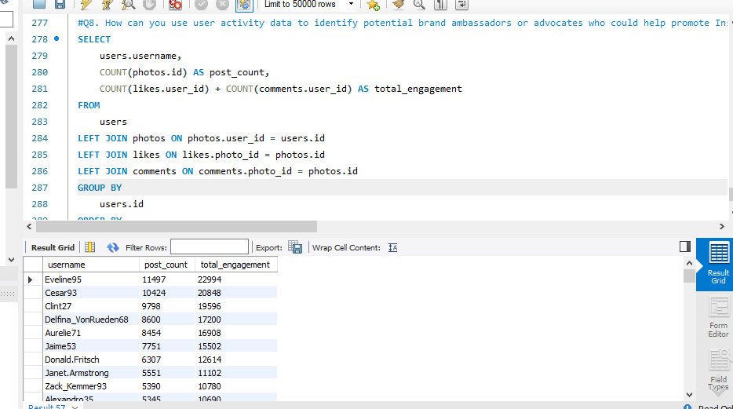  **Table:**

**Strategy:**

1. Offer perks like free merchandise or exclusive features to ambassadors.
2. Encourage them to promote events or campaigns with special hashtags.
3. How would you approach this problem, if the objective and subjective questions weren't given?

**Approach for Data Analysis Without Predefined Questions**

When no specific objective or subjective questions are given, the approach should be **exploratory and hypothesis-driven** to extract meaningful insights.

**1. Problem Definition & Goal Setting**

Clearly define what needs to be analyzed:

* **User engagement** (likes, comments, posts).
* **User retention** (active vs. inactive users over time).
* **Influencer identification** (high-engagement users).
* **Growth trends** (new users, popular hashtags).
* Understand business objectives to guide the analysis.

**2. Understanding & Preprocessing Data**

* Examine dataset structure, relationships, and column meanings.
* Check for missing data, duplicates, and inconsistencies.
* Normalize data formats for consistency (timestamps, categorical values).

**3. Defining Key Metrics & Indicators**

* **Engagement Analysis**
* Total likes, comments, and shares per user.
* Average engagement per post.
* Follower-to-following ratio.
* Time spent on platform (if available).
* **User Retention & Activity Trends**
* Number of active vs. inactive users (last 30 days).
* Frequency of interactions (daily, weekly, monthly).
* Churn rate: Percentage of users who stopped engaging.
* **Acquisition & Growth Trends**
* Number of new users per month.
* Influencer impact on new user acquisition.
* Most effective content types for audience growth.

**4. Trend & Pattern Analysis**

* Identify high-performing **hashtags** and content categories.
* Discover **peak engagement times** (day of the week, time of day).
* Assess **demographic patterns** in engagement (age, location, gender).
* Detect **viral content characteristics** (media type, captions, tags).

**5. Data Validation & SQL-Based Insights**

Use SQL queries to extract key insights:

**Engagement Trends:** SELECT user_id, COUNT(*) AS total_interactions FROM (SELECT user_id FROM likes UNION ALL SELECT user_id FROM comments) AS interactions GROUP BY user_id ORDER BY total_interactions DESC;

**Active vs. Inactive Users:** SELECT username FROM users WHERE id NOT IN (SELECT DISTINCT user_id FROM likes WHERE created_at > NOW() - INTERVAL 30 DAY UNION SELECT DISTINCT user_id FROM comments WHERE created_at > NOW() - INTERVAL 30 DAY);

**Influencer Detection:** SELECT user_id, COUNT(DISTINCT follower_id) AS followers, COUNT(DISTINCT likes.id) + COUNT(DISTINCT comments.id) AS engagement_score FROM follows JOIN photos ON follows.user_id = photos.user_id LEFT JOIN likes ON photos.id = likes.photo_id LEFT JOIN comments ON photos.id = comments.photo_id GROUP BY user_id ORDER BY engagement_score DESC LIMIT 10;

**6. User Segmentation & Targeted Strategies**

* **Segment users** based on engagement levels (high, medium, low).
* **Personalized content recommendations** based on past interactions.
* **Re-engagement strategies** for inactive users (notifications, incentives).

**7. Reporting & Visualization**

* **Dashboards & Reports** using:
* **Bar charts** for engagement by day.
* **Heatmaps** for peak activity times.
* **Pie charts** for user demographics.
* **Line graphs** for trend analysis.
* Present insights in a **clear and actionable** format for stakeholders.

**8. Continuous Monitoring & Optimization**

* Implement **real-time tracking** of user activity.
* Use **A/B testing** for content and ad strategies.
* Adjust platform features based on user behavior trends.

**10.** Assuming there's a "User_Interactions" table tracking user engagements, how can you update the "Engagement_Type" column to change all instances of "Like" to "Heart" to align with Instagram's terminology?

#### ****Query:****

UPDATE User_Interactions

SET Engagement_Type = 'Heart'

WHERE Engagement_Type = 'Like';

#### ****Explanation:****

This query ensures consistency in engagement terminology, reflecting Instagram's branding updates.

**Thank You !!!**